|  |
| --- |
| Imagine Dragoons |
| Assessment 2 |
| Team Project |

|  |
| --- |
| Ryan Williams, Benjamin King, Morgan Cassar, Douglas Baker, Ty Lynch-Palmer, Robert Cross |

Team Profile 3

Robert Cross 3

Meyer-Briggs Test 3

Personality test 4

Numeracy Test 4

Ryan Williams 5

Meyer-Briggs Test 5

Learning style Test 5

Psychometric Test 6

Benjamin King 7

Myer-Briggs Test 7

Learning Style test 7

Personality Test 7

Douglas Baker 8

Myer-Briggs Test 8

Myer-Briggs/Jung test 8

Big 5 Personality Test 9

Ty Lynch 10

Myer-Briggs Test 10

Learning Style Test 10

Big 5 Personality Test 10

Morgan Cassar 11

Myer-Briggs Test 11

Learning Style Test 11

The Big Five Personality Test 11

Comments 12

Robert Cross: 12

Ryan Williams: 12

Benjamin King: 12

Douglas Baker: 12

Ty Lynch: 12

Morgan Cassar: 12

Tools 13

Links to the team resources 13

Team Website 13

Team GitHub 13

Industry Data 14

Groups Ideal Jobs 14

IT Work 19

Interview Transcript 19

Interview Video 23

# Team Profile

Each group member's tests that were completed in assignment 1 have been listed below.

### Robert Cross

#### Meyer-Briggs Test

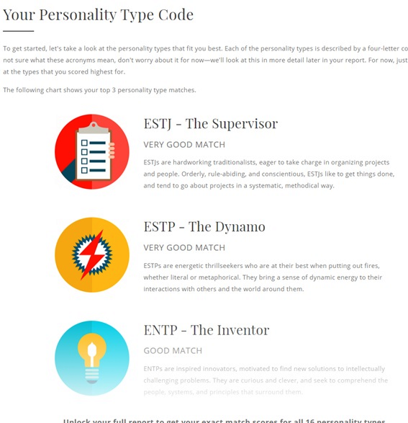

#### Personality test

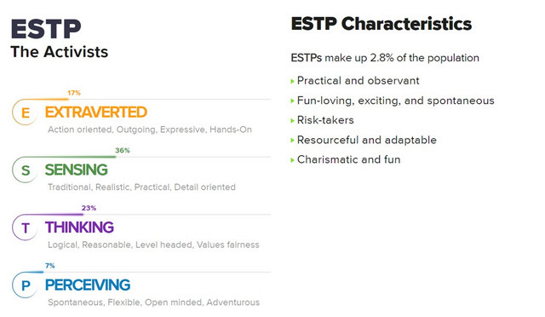

#### Numeracy Test

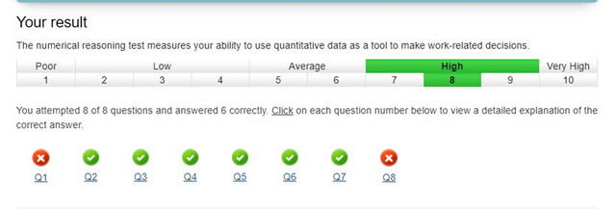

### Ryan Williams

#### Meyer-Briggs Test

[*https://www.16personalities.com/profiles/2b0ec0d4ce2f1*](https://www.16personalities.com/profiles/2b0ec0d4ce2f1)

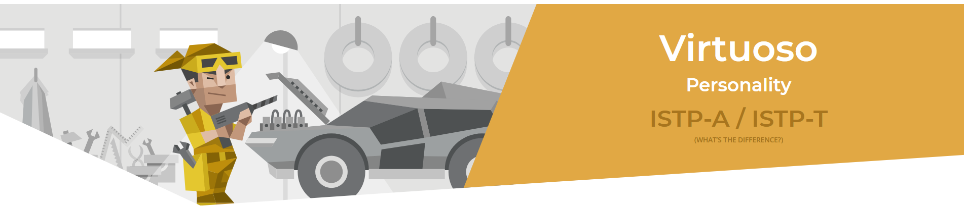

#### Learning style Test

[*https://ryan-williams1.github.io/IIT/Learning_Style_Results.pdf*](https://ryan-williams1.github.io/IIT/Learning_Style_Results.pdf)

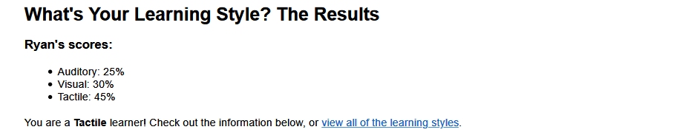

#### Psychometric Test

[*https://www.carecareers.com.au/quiz/result/id/1354786/token/6f539e2e#.XpmP6JnhWUl*](https://www.carecareers.com.au/quiz/result/id/1354786/token/6f539e2e#.XpmP6JnhWUl)

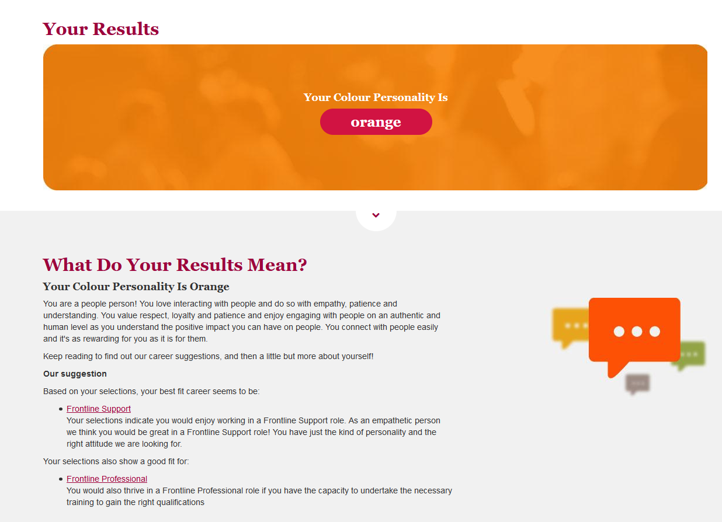

### Benjamin King

#### Myer-Briggs Test

[*https://www.16personalities.com/infj-personality*](https://www.16personalities.com/infj-personality)

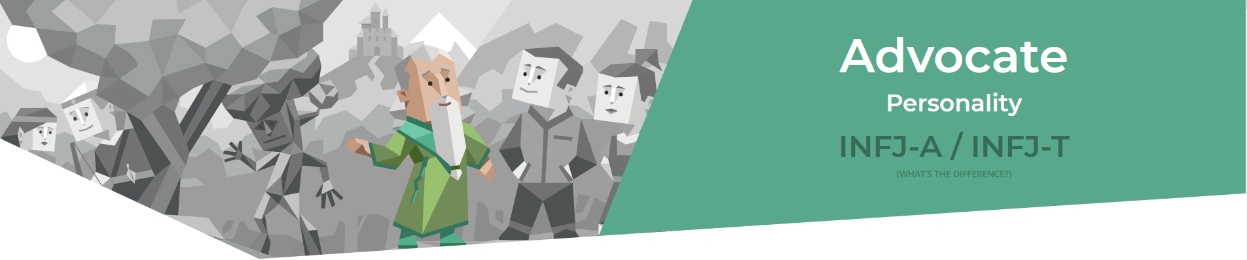

#### Learning Style test

[*http://www.educationplanner.org/students/self-assessments/learning-styles-quiz.shtml?event=results&A=7&V=6&T=7*](http://www.educationplanner.org/students/self-assessments/learning-styles-quiz.shtml?event=results&A=7&V=6&T=7)

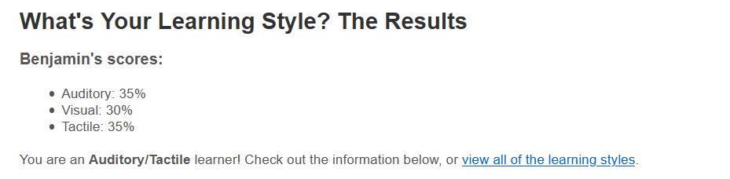

Personality Test

[*https://www.truity.com/test/big-five-personality-test*](https://www.truity.com/test/big-five-personality-test)

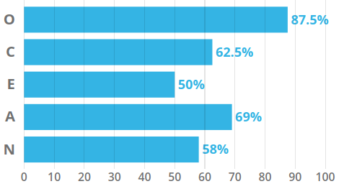

### Douglas Baker

#### Myer-Briggs Test

[*https://www.16personalities.com/istj-personality*](https://www.16personalities.com/istj-personality)

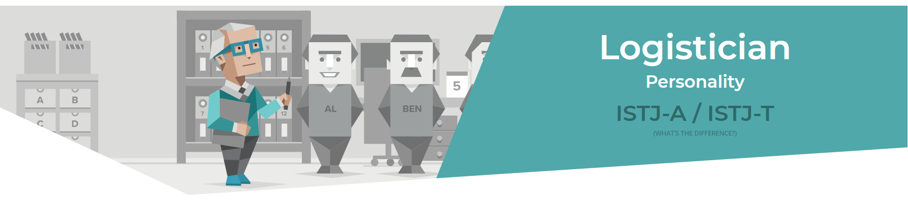

#### Myer-Briggs/Jung test

[*http://www.humanmetrics.com/*](http://www.humanmetrics.com/)

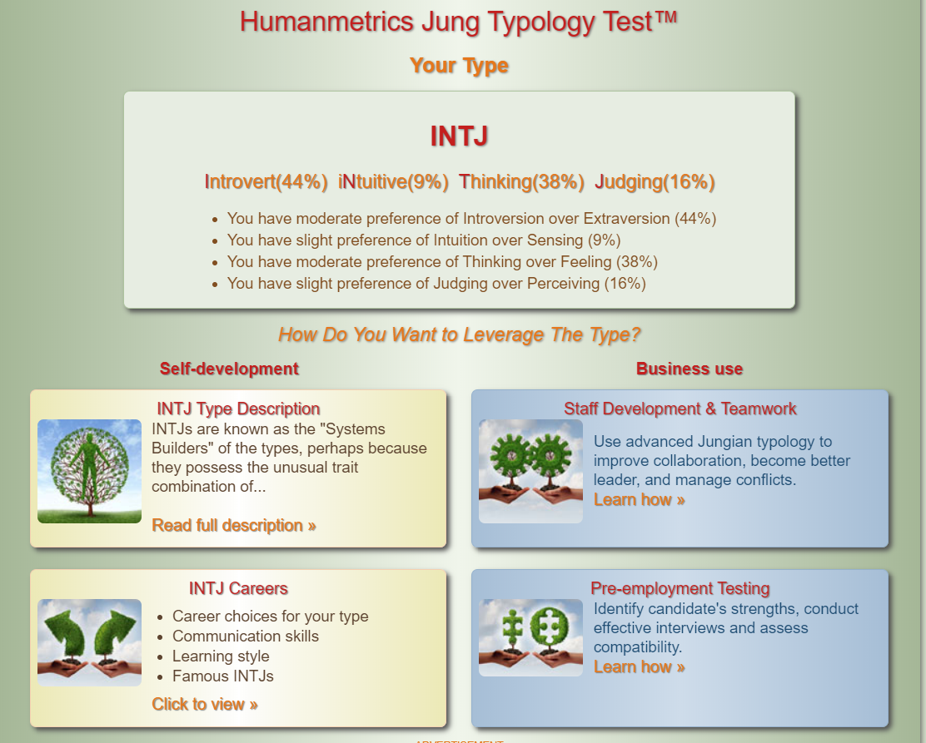

#### Big 5 Personality Test

[*https://www.truity.com/test/big-five-personality-test*](https://www.truity.com/test/big-five-personality-test)

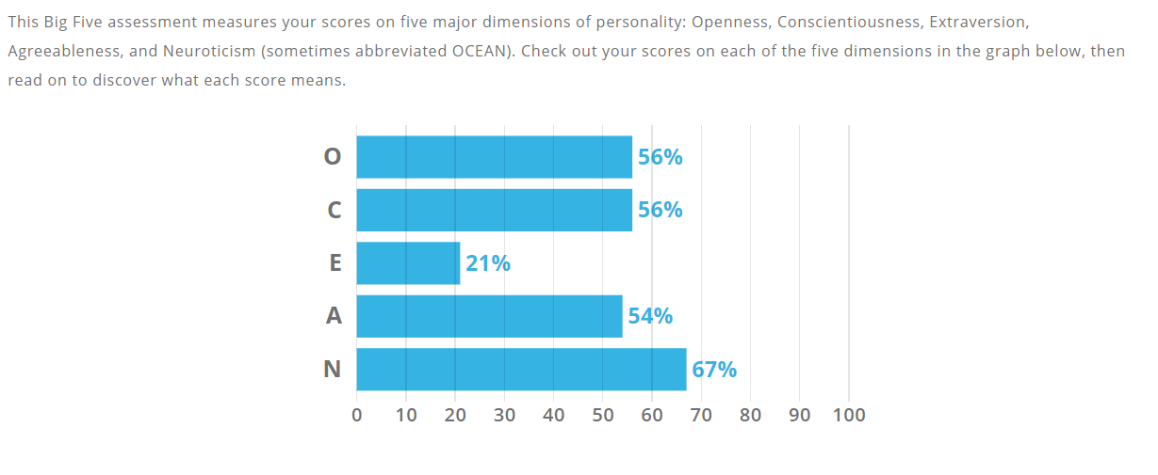

### Ty Lynch

#### Myer-Briggs Test

[*https://www.16personalities.com/istj-personality*](https://www.16personalities.com/istj-personality)

**

#### Learning Style Test

[*http://www.educationplanner.org/students/self-assessments/learning-styles-quiz.shtml?event=results&A=6&V=9&T=5*](http://www.educationplanner.org/students/self-assessments/learning-styles-quiz.shtml?event=results&A=6&V=9&T=5)

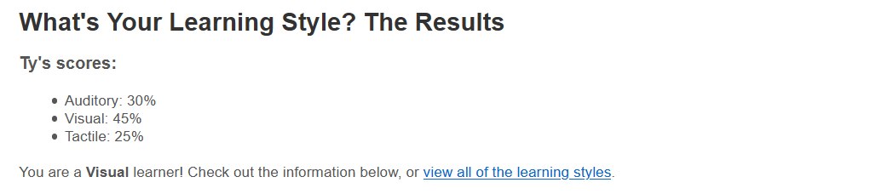

#### Big 5 Personality Test

[*https://www.scienceofpeople.com/personality-quiz-results/?score=386050647.14*](https://www.scienceofpeople.com/personality-quiz-results/?score=386050647.14)

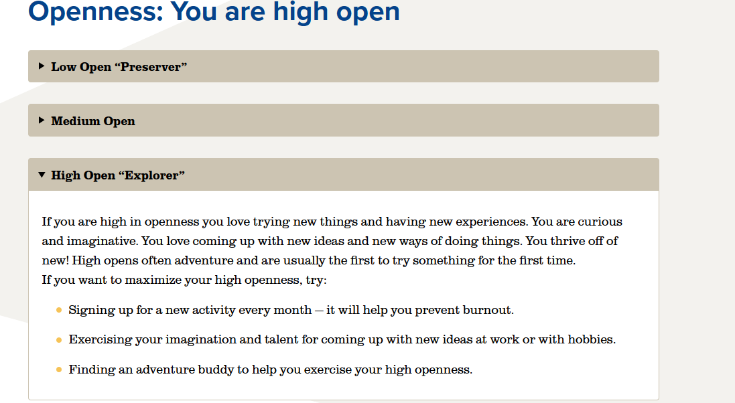

### Morgan Cassar

#### Myer-Briggs Test

[*https://www.16personalities.com/istp-personality*](https://www.16personalities.com/istp-personality)



Learning Style Test<http://www.educationplanner.org/students/self-assessments/learning-styles-quiz.shtml?>

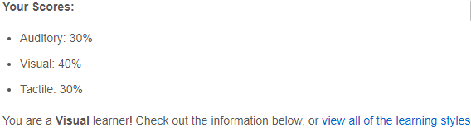

The Big Five Personality Test[*https://www.truity.com/test/big-five-personality-test*](https://www.truity.com/test/big-five-personality-test)

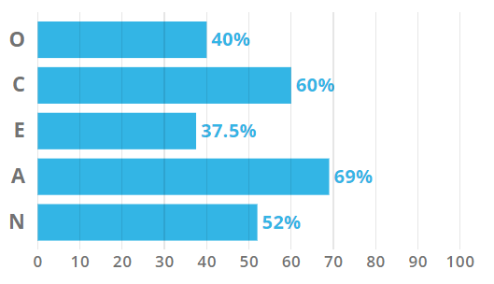

## Comments

### Robert Cross:

Across the entire group there is a diverse range of personality types as presented in the above results. I feel that in a larger group having a blend of personality and behaviour traits results in better communication overall and a more cohesive group. People will always prefer to work and divide tasks in a way that they feel comfortable doing and will potentially gravitate to different pieces of work depending on their personality trait e.g. web design over documenting a report. I think that given the range of personalities our team has worked well in dividing up the relevant tasks as well as communicating at a high level throughout the project. This may not have been possible if the entire team shared the same personality traits.

### Ryan Williams:

Having the same personalities test result can go either way, I feel having a mix of strong personality types has helped the team, being able to respect and understand opinions has been the foundation of this team, without everyone’s input the team would not have achieved what we did. Regardless of test results or personality tests, if the team is respectful and focused, they can meet all the goals set out. Our team has worked as a well-oiled machine (in between other life commitments) with no apparent issues.

### Benjamin King:

Any team is capable of working with differing types of personalities provided respect is shown by all members. Our team has shown that a range of personality types can work together well to achieve a common goal. I believe that our driving force was not so much our differing personality types, rather it is our interest and passion for all things IT related. It became very apparent quickly that we were all on the same page and that we had a good team on our hands.

### Douglas Baker:

From my experience any differing personalities in a team can work together if all the members make a decent attempt to work with each other. I have also found for myself if I can work with someone with some similar traits to myself it is often handy to highlight things that I may have overlooked.

### Ty Lynch:

I think that it is interesting that Douglas and I share the same results in the 16 personalities test which means we could either but head or work together quite well. Morgan and Ryan seem like they will make good team members willing to get in there and lend a hand where they can while also allowing others to have their freedom and collaborate on their tasks also. Benjamin’s 16 personality test mentions him being soft-spoken but from what I have seen so far, he is quite the leader organising the group in a fair and orderly manner. While it also seems Robert will make a good leader from his Myer-Briggs style test and his selection of job role.

Morgan Cassar:The fact that me and Ryan share the same result on our 16 personalities test means that I think we would work well together due to our personality type, being someone who is willing to work together on things towards a goal. Douglas and Ty, also share the same personality result, they are responsible people, and from what I can gauge from what they have done for this assignment, they have been very responsible, calm and practical and worked well with everyone in the group. Robert seems to have the personality who is dedicated, which he has shown through this assignment. Bens personality describes him as insightful and decisive, which he has shown throughout this assignment.

# Tools

We as a team used Microsoft Teams and GitHub to collaborate this project, Microsoft Teams was a valuable tool that enabled the team to communicate effectively. GitHub is was amazing and allowed a central file version which was updated by each member as needed, we also had a channel in Microsoft Team that was used for GitHub push and pull notifications to reduce possible push conflicts. The team assessment was broken into parts and our team opted for the divide and conquer approach, this allowed each member to have a small part then upload and communicate their findings.

The audit trail on GitHub reflects the teams work to a degree, it only shows when data was pushed to GitHub and does not reflect the work that each person put in, an example of this would be the interview, Douglas put in a lot of preparation time and gathered the questions from the team using Microsoft Teams but on GitHub it only shows a very small snapshot of that work in the audit trail. As a team we feel that relying on the audit trail is not a good measure of the work that everyone has put into the assessment.

Links to the team resources:

Team Website - <https://imagine-dragoons.github.io/RMITA2G15/>

Team GitHub - <https://github.com/Imagine-Dragoons/RMITA2G15>

# Industry Data

## Groups Ideal Jobs

Benjamin King: Cyber Warfare Officer

Douglas Baker: Systems & Network Engineer

Morgan Cassar: Cyber Security Manager

Ryan Williams: Senior Software Engineer

Robbie Cross: Chief Technical Officer

Ty Lynch: Senior C++ Engineer

The Burning Glass Top Occupations data set was used to rank each job title.

Roberts job title was not directly included in the data as such, he has been considered as a Computer Systems Engineer for this task.

1. Ryan Williams and Ty Lynch
2. Robert Cross
3. Douglas Barker
4. Benjamin King and Morgan Cassar

The skillset we have identified from the ideal jobs in assignment one has been divided into to two skill categories; General and IT-specific these are as follows:

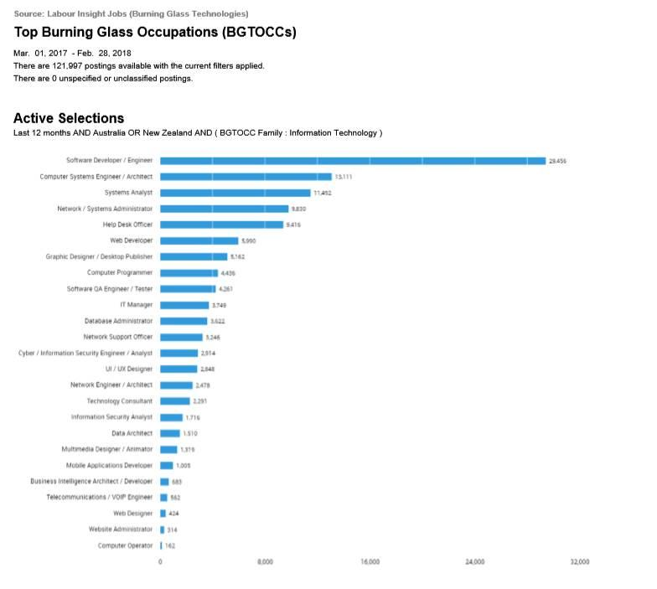

**General**

* Teamwork
* Communication Skills
* Leadership
* Team Management
* Organizational skills
* Problem Solving
* Troubleshooting
* Planning
* Meeting Deadlines
* Presentation Skills
* Writing
* Research
* English
* Business Management

**IT-Specific**

* Java
* JavaScript
* Python
* Postgres (SQL)
* Oracle
* Windows
* Linux
* Databases
* System Design
* Systems Engineering
* Software Engineering
* Technical support
* Project Management
* Customer Service

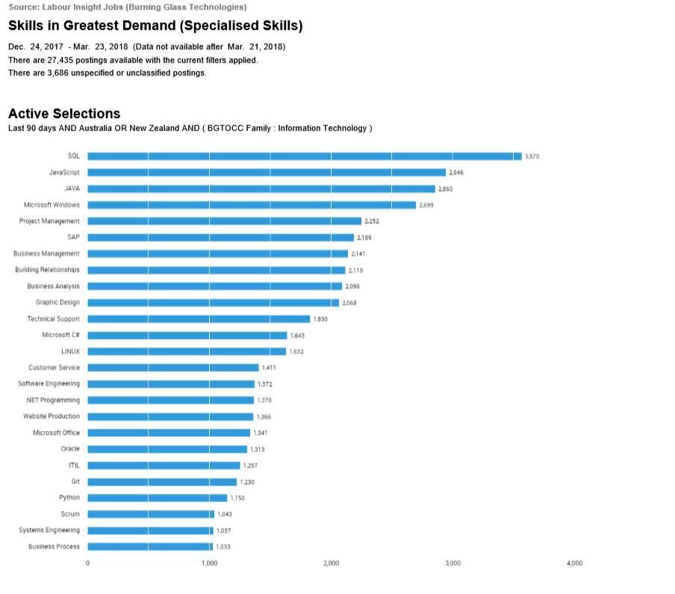

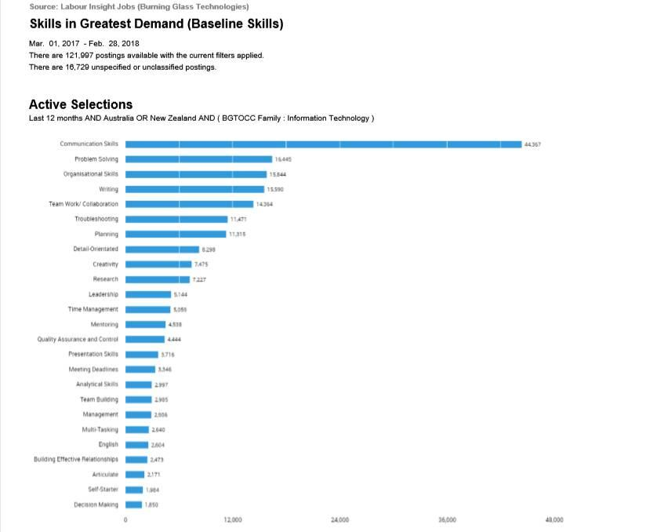

We think the skills our team members possess rank quite well in IT-specific skills when comparing to the data. Our team covers the top 5 skills and covers over half the skills in greatest demand. We are a very well-rounded group and because of this, we would be able to tackle a varied range of projects in a variety of different programming languages.

The team meets the top 6 highest-ranking skills in the general skills category. We meet half the required skills in this category. With all team members job roles requiring teamwork and communication skills we think we would make a great team.

The three highest-ranked IT-specific skills our team is missing are:

* SAP
* Building relationships
* Graphic Design

The three highest-ranked general skills that our team is missing are:

* Detail-Orientated
* Creativity
* Mentoring

• Having looked at the Burning Glass data, has your opinion of your ideal job changed? Why or why not?

Benjamin King:

After analysing the burning glass data my opinion of my dream job has been reinforced. Although the job title itself does not appear in the list I see that it’s equivalency is ranked high.

It is disappointing to see that the skill of using Linux isn’t ranked higher as I thought it would have been for a Cyber Warfare Officer but I am still pleased to see it in the middle range. The skills of leadership, teamwork, research and communication skills are surprising in their rankings but they still give my chosen role a high median. Overall I am pleased with the demands made by industry for my chosen job.

Ryan Williams:

After analysing the burning glass data my dream job has not changed, but maybe the specific language would be different. My dream job was a Java programming job but as the industry changes frequently it would be best to remain fluid with the industry and get experience in multiple languages. Regardless in how highly a specific programming language ranks in the data I still think that if you enjoy a job and the job compensation is enough to live comfortably, then that is all that counts.

Morgan Cassar:  
  
After looking at the burning glass data, I think I would still be interested in the job I researched in Assignment 1. It uses a lot of highly ranked general skills, such as communication skills and writing. It does not however rank as highly in IT-specific skills, with skills in Microsoft Windows being the only high ranked skill. Due to the nature of the job, cyber security, I do believe that it is an important field and that jobs will be in demand. It could however leave me out of the IT side of the industry as it only requires high levels of Microsoft Windows knowledge but leaves out a lot of other IT-specific skills. Pursuing this career, although may have lots of opportunities, it might stop me from branching out into a more IT-Specific job.

Robert Cross:

After analysing the burning data, I feel that the choice for my ideal job would remain unchanged. There is several specialised and general in demand skills outlined about that are relevant to a CTO position. It is also reassuring that having experience across a number of skills in the IT industry could also result in a change of direction in career paths or jobs in the future if I find another niche or skillset that may be more appealing e.g. software design or project management.

Douglas Baker:

Reviewing the data there is really nothing I would be changing about my ideal job. Being a Systems and Network Engineer does cover a wide breadth of skills and challenges that suits my personality. While it may be interesting to chase the high demand of Software Engineering, or to specialize in an area such as database administration, the skills that I do have are better tailored towards a generalist role.

Ty Lynch:

From analysing the burning glass data, I think my opinion has changed about the job that I would like to pursue. This is because the job I used in assignment one does not require the knowledge in most of the categories listed and the few that is does, it ranks quite poorly in the IT-specific field. It also requires hardly any skills in the general category although some skills may possibly be used that had not been listed in the advertisement. Following this career path may leave me in a niche industry, while it is a specialized industry and a passion of mine to work with games, it may close the door to other opportunities in the future. This could leave me stranded in that type of work, as it could possibly be difficult to branch out to another sector of the IT industry.

*References:*

1. [*https://rmit.instructure.com/courses/70682/files/10954610/download*](https://rmit.instructure.com/courses/70682/files/10954610/download?wrap=1)
2. [*https://rmit.instructure.com/courses/70682/files/10954543/download*](https://rmit.instructure.com/courses/70682/files/10954543/download?wrap=1)
3. [*https://rmit.instructure.com/courses/70682/files/10954568/download*](https://rmit.instructure.com/courses/70682/files/10954568/download?wrap=1)

# IT Work

## Interview Transcript

Interviewer – Douglas Baker – Imagine Dragoons, Team Member

Interviewee – Tom Gibson – LiveBetter, Network Engineer

Douglas: Ok I'm Interviewing Tom Gibson, who's a network engineer at LiveBetter. Tom, if you could tell us about your IT work and what you do during your day, and how that compares to your actual job description?

Tom: Yeah no worries. So as a network engineer at LiveBetter I am responsible for managing and maintaining the network, infrastructure, and connectivity between sites and employees to their services that they require to do their job. And I also act as an escalation point for service desk on any issues specifically relating to the network, but also some more generally IT troubleshooting. And then we also participate in project work and improvements and discussions and input on the strategic direction of IT in the business.

And, I guess yes it compared to my job description, I had a bit of a flip through that earlier on today just to check out what was in there and what I've been doing so. Yeah, I don't touch Azure as much as I thought I might, I guess, but I have been sort of touching that a little bit more recently there's less networking configuration in Azure now that our express-route links and everything are essentially already set up, so there's not a lot to play with in there. It's more systems management sort of setup, but other than that it lines up pretty spot on with the listed responsibilities.

Douglas: Yep, and how does it really compare to what people think that you do during the day?

Tom: Uh, yeah, not at all. Mention you are working IT to anybody, they just assume that you know you can fix their iPhone or their iPad or sort of any basic troubleshooting. Uhm, yeah, a lot of people that I talk to about it, especially people that don't have the strong IT background, just assume it's general “You know, my computer won't load this web page. Can you fix it for me?”

Douglas: “Have you tried turning it off and back on again?”

Tom: Yep. That’s the classic one

Douglas: Can you tell us about the actual industry that LiveBetter is in, and how it compares her other

industries that you've been involved with, with your IT work?

Tom: Yeah, so Live Better itself is an NDIS provider as well as they do Aged Care services and another Community Services as well. It's yeah significantly different from other industries I've worked in. I previously came from a managed service provider, so we ourselves were small business that provided services to multiple other small businesses, and they were typically small retail stores or sort of logistics companies and consultancy organizations and things like that.

Uhm, yeah, so its.... It's the work in LiveBetter is, more about, I guess managing a much more static and a stable network and one large, large corporate network servicing lots of disparate locations versus previously I was managing multiple smaller networks that didn't really interconnected in anyway.

Douglas: Yep, and other than, your real IT style of tasks that you have to do, what other things do you have to encounter during your day-to-day work?

Tom: Yes, as I touched on earlier the bulk of my work is around the project based stuff and the high end network, network engineer specific jobs. But, being that I'm located in Wagga and I’m the only IT person there I also do a little bit of service desk work I guess. There’s some small administrative stuff, around company credit card purchases and things, but, yeah, I'd say the vast majority is just pure IT work.

Douglas: What are the sort of different people that you have to interact with on a day-to-day basis, both inside LiveBetter and external to LiveBetter?

Tom: Yes, starts at the top of it, I

guess. So you've got there our executive members that are in charge of the Strategy Department of which IT sits inside LiveBetter, and that goes down the line from IT manages, to department managers

I guess you'd call it and team leaders, as well as colleagues, two other engineers at our level and there’s a Service desk that sits beneath us and then down to the customers, clients, employees. End users that are having the issues. Yeah, like the clients of the company as well are often still wandering around inside the Wagga office. And then there is also third party companies, people that they provide services to us or we get services from them. So postal office or shipping companies or people that are involved in providing our Internet connections.

Douglas: Yep. So what aspects of work do you spend the most time on?

Tom: Yeah, so I'd say typically the aspects take up the most time would be the project based work that we have. So there's a lot of sort of planning to either implement changes or improvements to the network, and there's a lot of time spent ensuring that those changes go smoothly, so there's a lot of planning and project work based around that. That, so depending on what project we're working on at any given time, that would take up the most amount. Closely followed

by escalations and things from the service desk, where issues have become greater than, the sort of first level knowledge, so we sort of chip in and help out with that.

Douglas: And that, in the project work, the change management side of things is quite a structured process there?

Tom: It is yeah. So um any, even off the back of service work I guess like if there's an issue that's been discovered and needs to have something significant changed inside the network to address it, then the whole process, starts up with, you know, submission of change requests, providing all the required information around that, and goes to a change management board meeting. They discuss the change and sort of highlight anything that needs to be addressed or, more information provided on. And then once that's approved, if it's approved, and then it goes into a big planning phase to

make sure that any changes to the network don’t cause anymore issues than were trying to solve.

Douglas: Yep, and also I guess, that includes the communication of when the changes happening and how it's going to impact the users and so on.

Tom: Yeah, that needs to get pushed out to all stakeholders, so that'll be if for example, we needed to swap a piece of hardware or upgrade bit of hardware it would be anyone who's having any contact with the network from employees on site at that point to all the systems engineers that would have applications that sort of run through and utilize that equipment as well.

Douglas: Which aspects of that project work do you find the most challenging?

Tom: At times, the most challenging part is the meetings, based around that work. There's a lot of I find myself, that actually gathering together all the requirements and the details and making sure you’ve thought of everything or that you've got everything covered. This is certainly, probably the most challenging part. The actual implementation of it, once you’re confident that everything is planned out, is, generally pretty breezy.

Douglas: Yeah, so several hours of work for a few minutes worth of results.

Tom: Yeah. A few minutes worth of play. That’s it.

Douglas: Are there any aspects of stuff that you'd rather spend less time on?

Tom: Yeah, look, I don't, despite the fact that the change management stuff takes a lot of time, but I probably wouldn't like to spend less time it. Because if I did I would be spending more time sweating as I try and fix things up. And I would probably say, Documentation is always a thing. Both before, during and after everything that you do, I'm always trying. Yeah, keep it, always try and keep everything that you do documented, but it be nice to be able to spend less time on it.

Douglas: Yeah, and when you are doing that work, are there any frameworks or methodologies that you try and work within to keep it structured and repeatable?

Tom: Yeah, so the main project, methodology, framework, I guess you could call it that we use is based around agile so, and we do lots of, sort of sprints. Yes, and any work that we've got allocated to a certain Sprint, will assign story points to, to give us an idea of workload at a current time and. We will go through numerous catch up meetings, standups during the week to get an idea of what work everyone's gotten, the progress of that work.

Douglas: Yep, and also I guess to accommodate the things that

change during that Sprint process as well.

Tom: Yeah, there's being sort of attached, symbiotic, I guess relationship with the service desk in that

where often fielding escalations from them. There's, some it can be very hard to plan for static events and block out all your time for certain tasks 'cause at any moment you could sort of be called upon to push that aside and address a critical issue.

Douglas: Now overtime, how have you found your work has changed?

Both in recent years as technology has shifted, and also with the recent shift of rather

than being in offices in, work from home, environments?

Tom: Yeah, I guess for me the biggest change is just sort of between employers. I guess I've been with Live Better for just over a year now and previous job was definitely, more structured around being in the office and making sure you're at this location, sort of sitting there with a team of people all the time.

At the moment, with Live Better. It's being the only IT person in Wagga, it's much more of a distance I'm

sort of feeling, so a lot of the meetings that I have, 90% of the

meetings that I have are via Teams, and so have been for awhile. Just because, you know, the core IT teams in a different location. So with the recent Corona, Corona pandemic that’s been happening and there's a shift for people to be working at home from that its actually made it pretty easy transition for me, 'cause it's not really a lot has changed day today for me. It's just the location in which I sit it's a little bit different.

Douglas: So yeah, and most of the items that you're actually working on, you’re remote from anyway, so...

Tom: Yeah, a lot of the tools that we have, you know a lot of our server access is set up in Azure. We use Office 365 for a lot of stuff, so a lot of that’s cloud based anyways.

Douglas: Now where do you see the next big change in your field, in particular is networking, where do you see that changing in the next few years and how will that affect the IT industry as a whole?

Tom: Yeah, look I think, networking specifically is, it's going to change with, sort of virtualized networks and uptake of SD WAN. So I think a lot of people, once they get all of their, network connection endpoints into the cloud based environment, being able to manipulate a lot of that, the framework I guess around those devices and having things template it out and. And having things. I don't know, I guess, a bit more centralized control and easily, easy to manipulate, on mass is going to change a lot, of the, of the networking side of computers and I think it's going to change it a lot for the better in that things will become more standardized and templated out and a lot easier to rollback changes if they need to be.

Douglas: Again on the IT industry. Is there an aspect of the industry that you'd like to change? And why would you like to change that, that aspect?

Tom: Yeah, maybe, um. Maybe a bit of the mystery and the elitism that can sort of happen a bit. There's a lot of. Um? There can be a lot of odd sort of, you have seen it a little bit in previous work places of people that have knowledge and don't generally like to share it as much. They like to hold on to the knowledge that they have in. I don’t know, but whatever their ego gets out of that, but I'd like to see a lot more, openness and sharing of information to hopefully sort of demystify a bit of what people do, and help everybody out I guess.

Douglas: I guess finally, can you share an example of the work that you do that best captures the essence of the IT industry? That sounds like a contains a lot of buzzwords for me “of the essence of the IT industry.”

Tom: What is the essence of the industry? I guess, as far as like the essence of a network engineer goes, an example of work that I do like. If I were to tell someone, you know if you're going to be a network engineer, this is the type of, stuff to look forward to. It's probably, setting up VLANs, configuration of switches and stuff with SSH. Doing all that remotely and interlinking different network sites I guess.

Douglas: Yep, so if we want to throw in some more buzzwords facilitation of the communication.

Tom: Yeah, that works good with some, uh, addressing the shifting paradigms.

Douglas: Yes, yes we need to include the word paradigms. OK, well I guess that, uh, that wraps it up. Thank you for your time and I'll let you go back to your normal day to day.

## Interview Video

Video file is located on the team GitHub page –

<https://github.com/Imagine-Dragoons/RMITA2G15/blob/master/Content%20Docs/interview-with-an-it-professional.compressed.mp4>